**GIT: Barcelona, Valencia & Madrid**

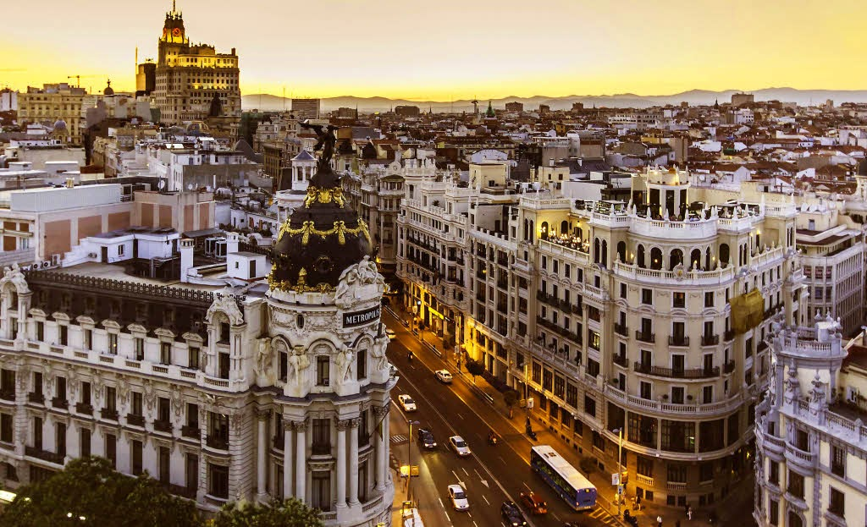 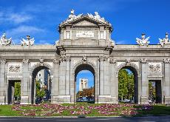 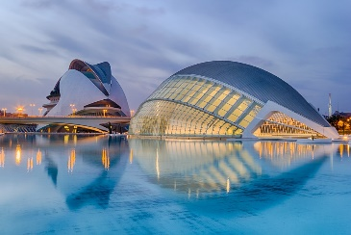 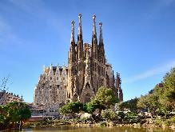

**day 1 Barcelona**

English speaking assistance upon arrival at **Barcelona** airport.

**transfer** to the hotel in the city.

leisure time in Barcelona, enjoy the city, especially during the night, the bars, the cafes.

overnight at hotel in Barcelona.

**day 2 Barcelona**

breakfast at the hotel.

half day **Barcelona** **sightseeing** on private basis.

*discover Barcelona with a general approach to its main tourist sights. a basic but complete itinerary will help you get to know the city by covering the most interesting places from the artistic and cultural point of view: the Gothic Cathedral, Plaça Catalunya, Passeig de Gràcia, Sagrada Familia.*

overnight at hotel in Barcelona.

**day 3 Barcelona - Valencia**

breakfast at the hotel and check out.

**transfer** to Valenciaby coach.

afternoon at leisure to discover the city, to go shopping or to go to the beach.

overnight at hotel in Valencia.

**day 4 Valencia**

breakfast at the hotel.

half day **Valencia sightseeing** on private basis.

*explore Valencia starting from* ***Plaza del Ayuntamiento*** *(town hall square), central*

*market, former* ***silk******exchange “La Lonja”,******Plaza de la Reina****, cathedral, Miguelete bell tower****, Turia river bed gardens, City of Arts & Sciences….***

overnight at hotel in Valencia

**day 5 Valencia - Madrid**

breakfast at the hotel ad check out.

**transfer** to Madrid by coach.

leisure time in **Madrid**, enjoy the weather and cuisine in Madrid or watch a football match.

overnight at hotel in Madrid.

**day 6 Madrid**

breakfast at the hotel.

half day **Madrid** **sightseeing** on private basis.

*this half-day visit offers a complete tour of the history and architecture of the city of Madrid. tour starts in the old quarters of Madrid and ends in the modern business area, in the following itinerary: Puerta de Alcalá, Cibeles, Puerta del Sol, Calle mayor, Plaza de la Villa, Plaza Mayor, Carrera de san Jerónimo, Calle Atocha, Reina Sofia museum, Atocha main railway station, Ministry of Agriculture, Prado museum, Banco de España, Paseo de la Castellana, Bernabeu football stadium.*

overnight at hotel in Madrid.

**day 7 Madrid**

breakfast at the hotel and check out.

**transfer** to Madrid airport.

**end of services**

**prices**

|  |  |  |  |  |  |  |
| --- | --- | --- | --- | --- | --- | --- |
| **package price per person** | **Nov - Mar** | | **Apr – Oct** | | **Jul - Aug** | |
| **standard class**  **\*hotels in Barcelona and Madrid located in outskirts** | **pax** | **€** | **pax** | **€** | **pax** | **€** |
| **15-19** | 455 | **15-19** | 507 | **15-19** | 493 |
| **20-24** | 392 | **20-24** | 443 | **20-24** | 428 |
| **25-29** | 354 | **25-29** | 403 | **25-29** | 389 |
| **30-39** | 318 | **30-39** | 365 | **30-39** | 352 |
| **40-49** | 289 | **40-49** | 336 | **40-49** | 322 |
| **single suppl.** | **157 €** | | **181 €** | | **187 €** | |
| **half board suppl.** | **98 €** | | | | | |
| **first class *hotel in Barcelona located in outskirts** | **pax** | **€** | **pax** | **€** | **pax** | **€** |
| **15-19** | 497 | **15-19** | 572 | **15-19** | 547 |
| **20-24** | 432 | **20-24** | 505 | **20-24** | 480 |
| **25-29** | 393 | **25-29** | 465 | **25-29** | 440 |
| **30-39** | 355 | **30-39** | 421 | **30-39** | 398 |
| **40-49** | 326 | **40-49** | 391 | **40-49** | 368 |
| **single suppl.** | **189 €** | | **237 €** | | **219 €** | |
| **half board suppl.** | **132 €** | | | | | |
| **superior class *hotel in Barcelona located in outskirts** | **pax** | **€** | **pax** | **€** | **pax** | **€** |
| **15-19** | 631 | **15-19** | 754 | **15-19** | 682 |
| **20-24** | 561 | **20-24** | 680 | **20-24** | 610 |
| **25-29** | 519 | **25-29** | 636 | **25-29** | 567 |
| **30-39** | 471 | **30-39** | 580 | **30-39** | 516 |
| **40-49** | 441 | **40-49** | 550 | **40-49** | 485 |
| **single suppl.** | **293 €** | | **361 €** | | **328 €** | |
| **half board suppl.** | **165€** | | | | | |

* prices per person based on double room & bb basis. minimum 15pax, maximum 49pax.

* one person in single room free of charge.

* prices subject to availability and possible fluctuations in any of the requested services at the time of final booking.

**validity**: **until October 2020.**

**inclusions:**

|  |  |  |  |  |
| --- | --- | --- | --- | --- |
| **city & nights** | **transfers** | **sightseeing on  private basis** | **meals** | **24h. phone assistance** |
| **2n Barcelona** | by coach | half day city tour | breakfast |
| **2n Valencia** | half day city tour |
| **2n Madrid** | half day city tour |

* one person free of charge.

**prices do not include:**

* regional tourist tax.
* tips and guests´ extras.
* any other service not mentioned on the programme / itinerary described.

**itinerary & number of nights**

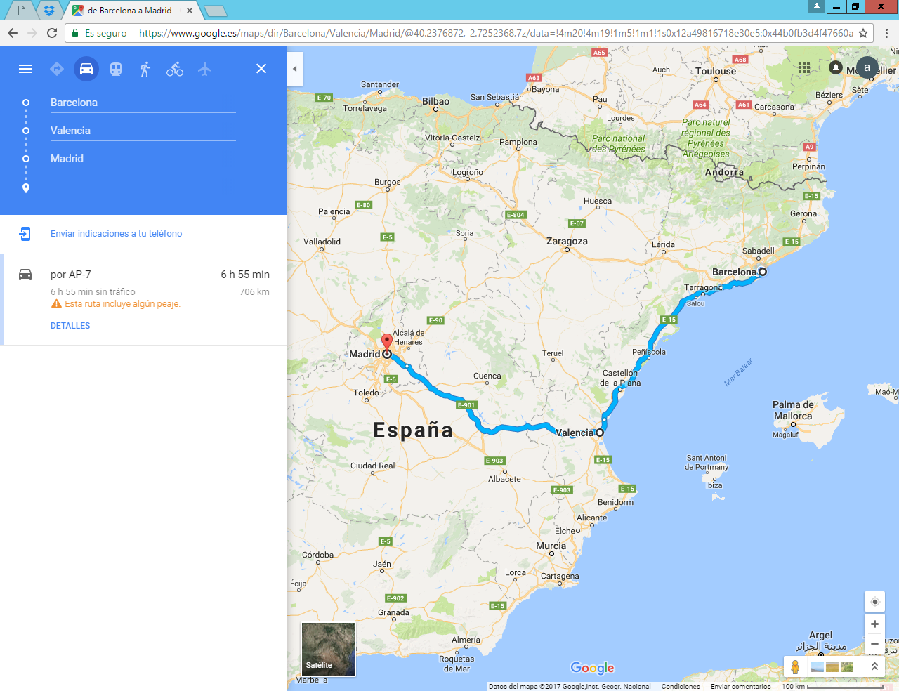

**2n**

**Madrid**

**2n**

**Valencia**

**2n**

**Barcelona**

